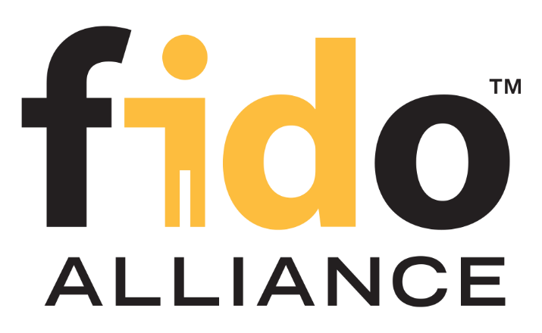

**Test Plan Template**

**(TOE Description**)

Version 1.0

21 October 2021

Revision History

|  |  |  |
| --- | --- | --- |
| **Date** | **Version** | **Description** |
| **2021-10-21** | 1.0 | Initial version |
|  |  |  |
|  |  |  |
|  |  |  |
|  |  |  |
|  |  |  |

Contents

**Introduction** **3**

​Audience 4

​Confidentiality & Copyright notice 4

Contact 4

​FIDO Secretariat 4

**Formal Information** **4**

Laboratory Details 4

TOE Details 5

**​TOE Overview** **5**

Overview 5

Verification of the version information 6

**Intended Environment** **6**

Hardware 6

Software 6

Physical Environment 7

**Appendix A: References** **8**

**​Appendix B: Terms & Abbreviations** **8**

# Introduction

This document serves as a template for a TOE Description for use in the context of the Identity Document Authenticity (DocAuth) Verification Requirements.

The guidelines contained herein are intended to provide a common ground and structure for all developers to prepare their TOE description for certifications.

## ​Audience

The primary audience of this document are developers of systems undergoing certifications according to the Identity Document Authenticity (DocAuth) Verification Requirements but it may be useful to all the parties involved in the Certification Program willing to have a deeper understanding of the Evaluation process.

## ​Confidentiality & Copyright notice

This document must be strictly confidential for only the FIDO certification team, the Accredited Laboratory, and the Vendor concerned in the current evaluation.

It is expected that the developer commits to share this document with parties having a legit interest in the certification of the system.

## Contact

### ​FIDO Secretariat

The FIDO Identity Verification Secretariat is responsible for reviewing applications, questionnaires, monitoring security threats, and acts as an independent expert for the FIDO Document Authenticity Certification Program.

For help and support, visit the FIDO Website [FIDO Cert] or contact the FIDO Biometric Secretariat at [identity-certification@fidoalliance.org](mailto:identity-certification@fidoalliance.org) .

# Formal Information

Please provide the following details.

## Laboratory Details

|  |  |
| --- | --- |
| **Laboratory Name:** |  |
| **Evaluator(s) Name:** |  |

## TOE Details

|  |  |
| --- | --- |
| **Vendor Company Name:** |  |
| **Vendor Contact Name:** |  |
| **Vendor Contact Email:** |  |
| **Implementation Name** |  |
| **Version of the implementation** |  |
| **Version of Identity Document Authenticity (DocAuth) Verification Requirements** |  |

# ​TOE Overview

This chapter is intended to provide an overview over the system that should be certified. This system is also referred to as “Target of Evaluation (TOE)” in this context.

## Overview

Please provide a short overview over the TOE and its use case. Please make sure to cover

* A general overview,
* a process description, of how the TOE processes documents,
* a description of the speciﬁc Tier 3 and Tier 4 documents that the TOE supports,
* a description of the requirements that the TOE has for images to process (e.g. minimum resolution); vendors can set different requirements to evaluate different document sophistication levels.
* A description of the transaction policy of the TOE (i.e. how many attempts are allowed per transaction).
* A description of any parameters that can be used to adjust the performance or security of the TOE and their chosen settings.

## Verification of the version information

Please give a short description, how a user and the accredited laboratory can verify/check the version information of the system

# Intended Environment

This chapter should specify the intended environment for the TOE in terms of hardware, software and other environmental factors.

## Hardware

Please describe which hardware the TOE needs in its immediate environment. Examples could be a camera with a certain resolution or a CPU with a certain performance characteristics.

The definition of hardware can be addressed in two different manners:

1. By a complete definition of the hardware: e.g. “The TOE requires camera XYZ”
2. By a dedicated definition of all relevant hardware characteristics that the TOE needs

While the 2nd solution allows a greater flexibility, please note that this kind of definition is also more challenging. The laboratory will set up a test plan based on these descriptions and the developer shall make sure that the TOE really works on a hardware platform meeting the characteristics.

## Software

Please describe which software the TOE needs in its immediate environment. Examples could be an Android or iOS Operating System or also certain other software. Please note that the required software has to be clearly identified, including version information. While it is possible to specify that the TOE is intended to be used on a certain OS ranging from version x to version Y, it is not possible to specify that the TOE is intended to be used on an OS version X or higher (as this would include unknown versions).

The software that is needed by the TOE can best be specified in the form of a table as the following.

|  |  |  |
| --- | --- | --- |
| **Software** | **Version** | **Used for** |
|  |  |  |
|  |  |  |
|  |  |  |

## Physical Environment

Please briefly describe the environment that the TOE is intended to be used in. This specifically includes the definition of all environmental aspects that are relevant for the performance of the TOE.

If the TOE is intended for use in multiple environments, please specify each environment in a separate subchapter and provide a speaking name. The intended environment(s) that is chosen for testing, will be identified on the certificate using this name.

# Appendix A: References

|  |  |  |
| --- | --- | --- |
| **Reference** | **Title** | **URL** |
| [FIDO Cert] | FIDO Certification Website | https://fidoalliance.org/certification/ |
| [DocAuth] | Identity Document Authenticity (DocAuth) Verification Requirements |  |

# ​Appendix B: Terms & Abbreviations

|  |  |
| --- | --- |
| **Term / Abbreviation** | **Definition** |
| **CC** | Common Criteria |
| **CWG** | Certification Working Group |
| **PP** | Protection Profile |
| **FER** | FIDO Evaluation Report |
| **RP** | Relying Party |
| **SRWG** | Security Requirements Working Group |
| **Security Requirements Working Group** | FIDO Working Group composed of FIDO member companies that define the requirements for the Security Certification Program and act as Security Experts for FIDO. |
| **Accredited Laboratories** | Laboratories that have successfully completed the FIDO Laboratory Accreditation Process and have a valid Certificate of Accreditation. |
| **Vendor** | FIDO member organization or non-member organization seeking FIDO Certification. |
| **Security Secretariat** | FIDO Staff responsible for reviewing applications, questionnaires, monitoring security threats, and acts as an independent FIDO security expert for the FIDO Security Certification Program. |
| **Accreditation** | Formal recognition that a Laboratory is competent to carry out specific tests or calibrations of types of tests or calibrations. Accreditation does not imply any guarantee of Laboratory performance of test/calibration data. |
| **Certificate of Accreditation** | Document issued by FIDO to a Laboratory that has been granted FIDO Accreditation. |
| **TOE** | Target of Evaluation |